Grant Culver

Back End Web Development

Final Project

For my final project, I would like to create an inventory management system that helps the company I work for better stock new vehicle inventory. For the last 15 years, I have worked as a general manager for a new car dealership. One of the problems that we run into is stocking new vehicles. Currently, without paying for expensive 3rd party software, we use excel spreadsheets and several other systems to determine a “model inventory”. One of the problems with this approach is it is not an analytical approach to stocking inventory. For starters, our current solution requires utilizing three different systems to gather the information and then meshing it together in a single spreadsheet. This wastes time, resources and energy that could be better utilized on differing tasks. Secondly, our approach relies too much on what someone thinks we should be stocking and not enough on what the numbers say we should be stocking. This program could be dumbed down to as little as pulling the inventory from a database and then calculating and displaying the information to the user for order placement. Or the system could be expanded by tapping into our inventory database, DATA.GOV and the factory website to fully analyze not only dealership trends but also local market conditions (based off of vehicle registrations from DATA.GOV) and comprehensively develop a strategy to not only analyze our current sales history but also analyze the local competitors. This solution could be further expanded on by utilizing a web scraping application that could analyze days in inventory, competitive pricing models, etc. but that would probably put this project out of scope for the time period of class. My idea is to create and build on an idea at some further point in time.

I believe the website would work obviously by creating an Angular application utilizing the rest of the MEAN stack. The application would have an authentication sign-in page that would ensure authorization to access the site. Once authentication was achieved the site would take the user to a dashboard page that would allow for the user to see current inventory in-stock by make and model. Also, the user would be able to see make and model selling history for a determined amount of time. Initially, the user would need to configure the settings for determining what the model inventory would look like. Typically, model inventories are calculated in terms of a month supply. Months supply is determined by taking units sold (filtered by make or model or both) divided by a given number of months and then multiplying that number by the desired months supply. As mentioned, this metric varies by dealership and would need to be completed by user upon initial deployment of application. After initial settings, the program would need to retrieve both units in stock and units sold for a given time period from a database. The program would then calculate the months supply from retrieved sold inventory and calculated model inventory both by overall make and then more granularly by make and model. This information would be displayed to the user.

I have included several screenshots of the proposed system to-be. As mentioned, initially the user would need to login via a login screen.

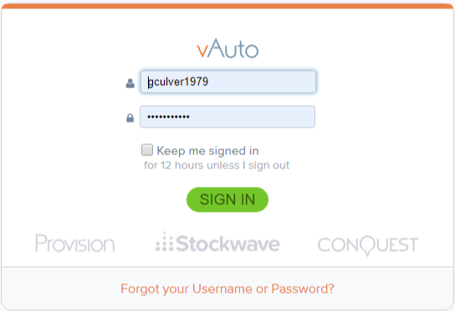

After logging in the user would initially need to set up settings for model inventory. I don’t yet have a photo example of what this might look like, but it would be rather basic.

Next, after clicking a button to retrieve current inventory from a database the solution would provide a screen resembling the screen below. This excel spreadsheet tracks our inventory and lets our dealership personnel know whether we need inventory or do not need inventory. It provides this information both by a general make and also a more granular level of model.

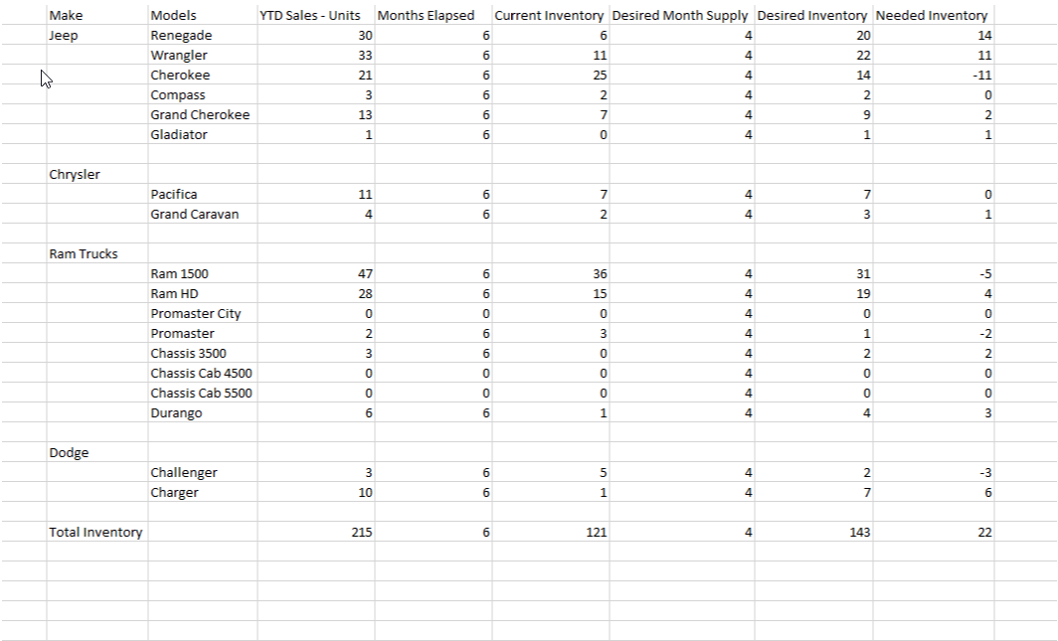

I think that the proposed project would be attainable to a certain degree, I think that being able to expand on the project past this current semester could be beneficial to our dealership. There are numerous add-ons that could be expanded to make the application more robust and profound. Please let me know your thoughts on my current proposal.